Course 4

**CB Full Stack - Integration and Deployment**

**Docker**

**CI and CD tool using Jenkin Configuration**

**AWS modules**

**Angular Application – Frontend --- Spring boot backend -🡪 mysql database**

**Adding more functionality.**

Docker is an open source software platform or Docker is a advanced VM. That helps us to simplify the process of creating , managing, running and distributing our application. With Docker you can package our application along with its dependencies into a container.

Docker allow your application to be deployed easily.

To the application software or tool or product we need system software ie OS.

OS can be window, linux, unix, mac etc.

IBM : MQ or MB,

SAP modules

Sales force

My OS is window 11

Unix OS.

One machine or One OS.

One machine we can run multi OS.

VMware software

Oracle VM box

First we need to install VMWare software in base machine

With help of VMware software we can run different OS like mac, unix, or linux .

Base Machine 🡪 Window with RAM 16 GM memory : 550gb

Running another OS with help of

VMWare ie Unix -🡪 4gb 50gb external memory

If we need to run 10 OS using VMWare

Each OS we can provide 1gb RAM

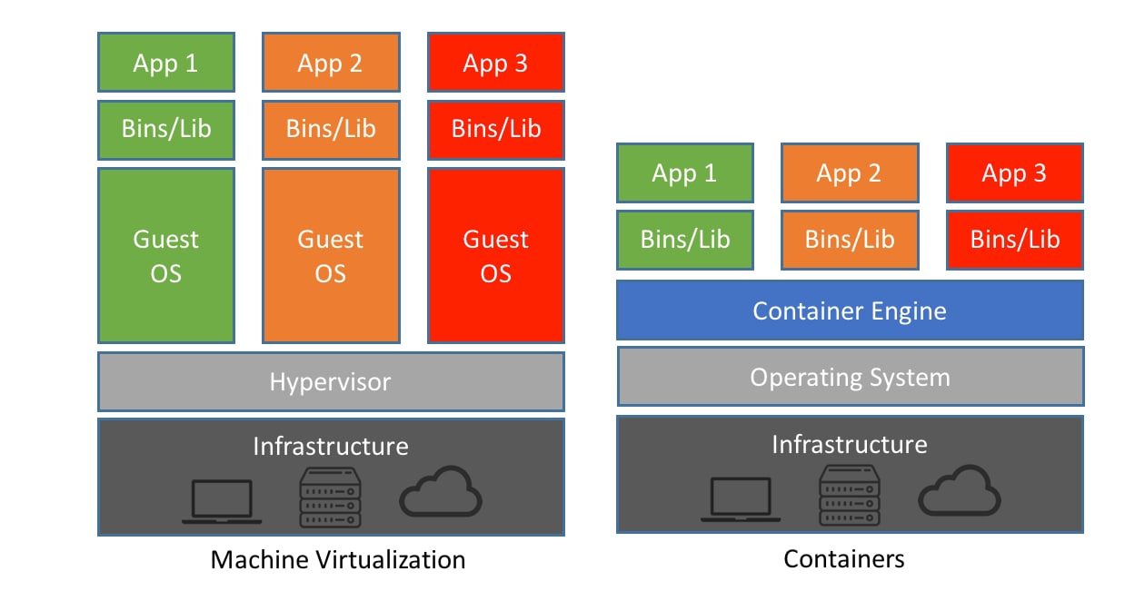

In VMware software base OS need to share the resource to Guest OS.

Virtualization : using VM software we can do Virtualization means running OS virtually. Virtualization is an abstract version of OS.

Containerization : using Docker we can create Containerization. With help of containerization we can do abstract of an application.

If we develop application software using some technology like Java, python, php, angular etc.

If I, develop application using angular – spring boot and mysql database.

You need to install node js to run ng command which help to run angular application

You need to install java to run spring boot application

You need to install mysql database to run database.

Rather than this with help of Docker I create Docker Image.

Then I share Docker image to you.

With help of an image you can run that application without installing any required software or dependencies in you machine. But Docker software must be present in your machine.

Open the command prompt or terminal

docker --version

non window user

sudo docker –version

docker images this command is use to display all images present in local machine.

docker pull imagename : this command is use to pull the image in local machine

docker pull hello-world

docker run imageName/imageId

Docker hub account create

Docker hub : it is an open source remote repository which help to public as well as pull and push images. It is like a Github. But github we an push any type of file. In Docker hub we need to publish or push docker images.

Docker pull hello-world : Hello world is a one of the type of image present in Docker hub repository.

Once you write Docker pull imageName. First Docker check that images present in local machine or not. If not present then by default it will pull that image from Docker hub account to local machine.

Docker images is responsible to run the application.

Docker Image Docker image is a ready -only template file. This image file contains an executable package of software that includes everything needed to run an application in Docker container.

Docker container : it is an run time environment which help to run the application using docker image. Docker container is light weighted container.

Docker is a virtual environment that bundles the application code (in the form of Image) with all the dependencies required to run the application.

docker run hello-world

this image is responsible to run the C program.

In local machine C software not present only docker engine or docker desktop or docker software present.

We can’t run application software without system software.

Docker provide OS images which help to run the application software develop in any language.

Busybox